A Custom Anomaly Detector for Laptops or Workstations
by Marcos Fernández

Introduction and Problem Description
The goal of this project is to build an anomaly detection system for a standalone device. The system is designed to run on a personal laptop with Windows and continuously monitor some performance indicators in order to detect anomalies.

In this project, an anomaly is considered as a situation in which the system behavior is clearly different from what is normally observed during everyday usage. This can happen, for example, when the CPU or RAM usage suddenly becomes very high due to a faulty program, an infinite loop, or other unexpected activity. Detecting this kind of behavior can be useful to improve system monitoring and to identify potential problems at an early stage.

The proposed solution was developed step by step. First, a monitoring component collects system performance data at regular time intervals. In my project, data is collected every 1 second. Then, a dataset is created by combining normal system behavior with anomalous behavior generated in a controlled way. Based on this dataset, different machine learning approaches were trained and evaluated in order to understand which one performs better for anomaly detection. Finally, the selected model was integrated into a runtime detector that analyzes live system data and classifies each observation as normal or anomalous.

The final result is a simple but complete anomaly detection system that works in real time, prints the detection results on screen, and stores both the monitored values and the predictions in a log file which can be analyzed later.

System Monitoring Design
In my project, system monitoring was implemented using a custom Python script (monitor.py). The goal of this component was to periodically collect a set of performance indicators from the operating system and store them in a simple format that could later be used for data analysis and model training.

The monitoring process was based on the data collected in each interval of 1 second. This value was chosen as a good compromise between temporal resolution and system overhead. A shorter interval would generate unnecessary noise and larger datasets, while a longer interval could miss short but relevant changes in system behavior, especially during anomaly injection.

The monitor collects the following performance indicators:
- CPU usage percentage
- RAM usage percentage
- Disk read and write activity
- Network sent and received activity

CPU usage was selected as the main indicator for anomaly detection, since in my laptop, in the normal everyday usage it usually remains relatively low and stable as shown in the metrics. Sudden and sustained increases in CPU usage are often a clear sign of abnormal behavior, such as faulty programs or infinite loops. RAM usage was included to provide additional context about the system state, even though it is often high during normal usage on modern systems and in particular, in my laptop with just 8 GB of RAM, so it barely changes during the injection, firstly because the injection is focused on the CPU, and secondly because the percentage of used RAM was already high. Disk and network activity were also monitored as secondary indicators, since abnormal behavior can sometimes affect input/output operations or network traffic.

Example of monitored system metrics collected during execution:
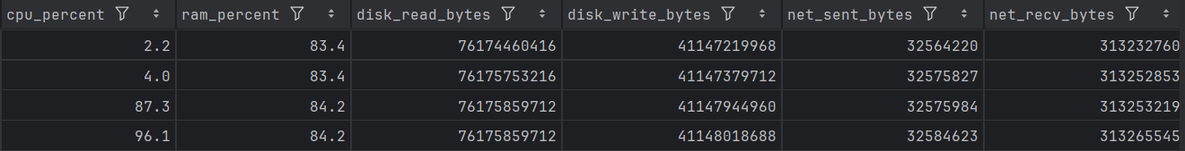

The monitoring script runs continuously and stores the collected data in a CSV file (system_metrics.csv). This format was chosen because it is simple, lightweight, and easy to process using common data analysis libraries. Each row of the file corresponds to one timestamped observation of the system state.

Dataset Creation and Anomaly Injection
In order to train and evaluate the anomaly detection models, a labeled dataset (dataset_labeled.csv) was created using data collected by the system monitoring component described in the previous section. The dataset includes both normal system behavior and anomalous behavior generated in a controlled way.

First, data corresponding to normal behavior was collected by running the monitoring script while using the laptop in a standard way. During this phase, no specific actions were performed to stress the system, and the collected data represents the typical performance of the device during everyday usage.

To generate anomalous behavior, a custom anomaly injection script was implemented. In my project, the anomaly injection focused on CPU usage, since CPU was selected as the main indicator for anomaly detection, as already explained. The script (inject_cpu.py) generates a sustained and intensive CPU workload for a fixed amount of time (60 seconds), simulating abnormal behavior such as faulty programs or infinite loops. This approach was chosen because it is simple, reproducible, and produces a clear deviation from normal system behavior.

During the anomaly injection process, the monitoring script (monitor.py) was kept running continuously. The exact start and end times of the injection were recorded using timestamps. Based on these timestamps, the collected data was labeled as follows: observations recorded during the injection interval were labeled as anomalies (label = 1), while all other observations were labeled as normal behavior (label = 0). This labeling process allowed the creation of a supervised dataset that could be used both for training and evaluating different machine learning models.

Some monitored indicators, such as disk and network activity, are provided by the operating system as cumulative counters. In order to better represent the actual activity of the system over time, these values were converted into per-second variations by computing the difference (delta) between consecutive measurements. This preprocessing step makes the dataset more suitable for anomaly detection, since it reflects real activity instead of accumulated values.

Example of the code used to compute the difference between consecutive counters:
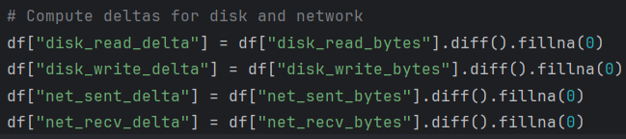

The final result of this process is a single labeled dataset stored in a CSV file (dataset_labeled.csv), which contains timestamped observations of the system state together with the corresponding anomaly label. This dataset represents the basis for the training and evaluation of the anomaly detection models described in the next section.

Anomaly Detection Models and Evaluation
Once the labeled dataset was created, different machine learning approaches were trained and evaluated in order to perform anomaly detection. The objective of this phase was to compare different types of models and select the most suitable one for this job.

As a first approach, an Isolation Forest model was trained. This algorithm is unsupervised, meaning that it does not rely on labels during training. Isolation Forest was selected as a baseline model to understand how well anomalies could be detected by learning only the normal behavior of the system. The model was trained using the collected features and evaluated by comparing its predictions with the available labels. The results showed that the model was able to detect a fraction of the injected anomalies, but its overall performance on the anomaly class was limited. It showed a F1 score of 0.4 which is lower than the score obtained with the second model.

As a second option, I tried using a Logistic Regression model, which was trained using the same dataset. Unlike Isolation Forest, Logistic Regression is a supervised learning algorithm and therefore takes advantage of the labeled data created during the anomaly injection process. This model was chosen because it is simple and well suited for binary classification problems. It showed a F1 score of 0.9375 which is much better than the one obtained with the Isolation Forest model.

Classification report using the Logistic Regression model:
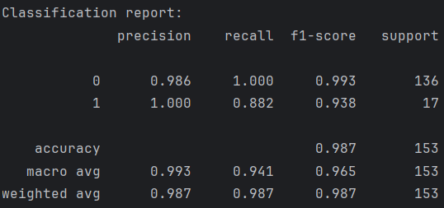

Since anomalous samples were much fewer than normal ones, class balancing was used so that errors on anomalies were not ignored during training.

Class balancing adjustment:

For the evaluation of both models, the F1-score for the anomaly class was selected as the main performance metric. This metric was chosen because the dataset is imbalanced (more normal than abnormal samples) and the correct detection of anomalies is more important than overall accuracy. The comparison showed that Logistic Regression significantly outperformed Isolation Forest in terms of anomaly detection performance, achieving a much higher F1-score for the anomalous class.

Based on these results, Logistic Regression was selected as the final model for the anomaly detection system. It provided the best trade-off between detection performance, simplicity, and interpretability, making it very suitable for integration into a real-time anomaly detector, the final goal.

Runtime Anomaly Detector Integration
After selecting Logistic Regression as the final anomaly detection model, it was integrated into a runtime anomaly detection system. The objective of this final step was to combine system monitoring and model inference in order to detect anomalies in real time on the running device.

The runtime detector was implemented as a Python script (runtime_detector.py) that continuously collects system performance metrics using the same indicators and sampling interval adopted during the data collection phase. This ensures consistency between the data used for training the model and the data analyzed at runtime. At each second, the script reads the metrics, computes the deltas for disk/network counters, and then the model outputs NORMAL or ANOMALY.

For each new observation, the model outputs a prediction indicating whether the current system state should be considered normal or anomalous. This prediction is immediately printed on screen, allowing the user to observe the system behavior in real time.

Console output example:
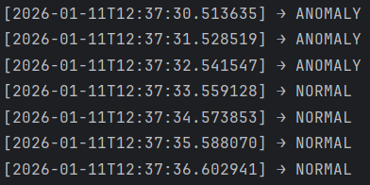

In addition to the console output, all monitored values together with the corresponding prediction are stored in a CSV log file (runtime_log.csv). This allows the runtime behavior of the detector to be reviewed and analyzed after execution.

The runtime detector was tested by running it under normal system conditions and then executing the anomaly injection script in parallel. During normal operation, the detector consistently classified the system state as normal. When the CPU anomaly injection was activated, the detector correctly identified the anomalous behavior and reported anomaly detections in real time. After the injection ended, the detector returned to normal predictions.

This final integration step shows that the system is able to detect anomalies in real time on a standalone device, completing the workflow from data collection and model training to runtime execution.

Conclusions
In this project, an anomaly detection system for a standalone device was implemented. System metrics were monitored, anomalies were generated in a controlled way, and different machine learning models were evaluated.

The results showed that Logistic Regression performed better than the unsupervised approach and was therefore selected. The final system was able to detect anomalous behavior during execution, in real time.

References
Scikit-learn documentation
Psutil documentation

